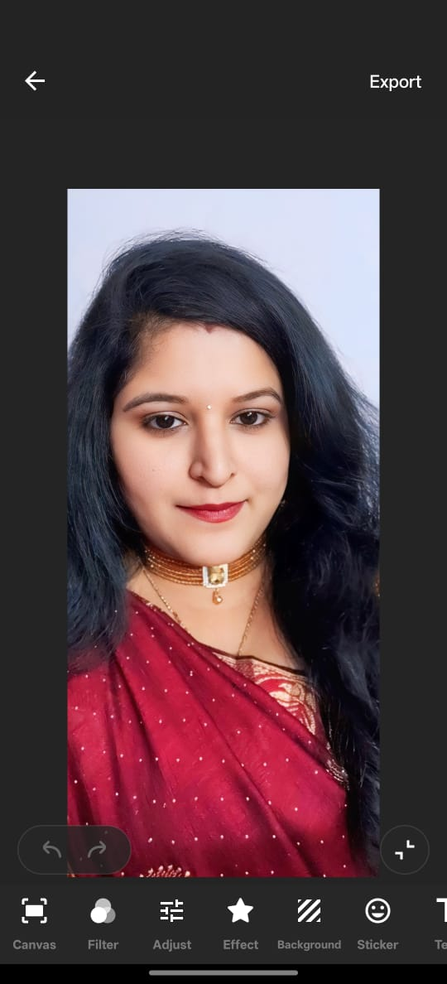

**LALITHA PRIYA. CH**  
📞 +91-7981276741 | ✉️ priyalalitha0911@gmail.com  
🌐 Hyderabad, Telangana, India

**PROFESSIONAL SUMMARY**

* Dynamic and results-oriented professional with over 10 years of experience in Operations, Training, Data Management, and Project Management. Proven ability to lead cross-functional teams, manage end-to-end project lifecycles, and deliver high-impact results.
* Adapt at stakeholder engagement, risk mitigation, process optimization, and continuous improvement. Seeking a role where I can apply my leadership, project execution, and operational strategy skills to contribute to organizational success.

**Core Competencies:**

* Project Management & Planning
* Operations & Team Leadership
* Master Data Management (MDM)
* Process Improvement & Optimization
* Stakeholder & Client Relationship Management
* Learning & Development (L&D)
* Risk Management & Escalation Handling
* KPI Monitoring & MIS Reporting
* Content Development & Virtual Training
* MS Excel (Advanced), PowerPoint, Zoom, Teams

**Certifications**

* Six Sigma – Yellow Belt
* Lean Management
* Agile Fundamentals
* TQM (Total Quality Management)
* PMP (In Progress)

**Projects:**

* **Lean & Six sigma Projects**
  + Conducted a Value Stream Mapping (VSM) exercise across the new hire onboarding and post-training performance tracking workflow.
  + Identified redundant touchpoints, delays in content delivery, and manual reporting efforts.
  + Streamlined communication between training, HR, and operations, eliminating repeated documentation and delays in floor deployment.
  + Introduced **checklists, automated reports**, and a centralized SOP repository to standardize tasks.
  + Integrated lean principles into daily stand-up reviews and feedback loops.
* **Process Optimization & SLA Alignment – LYROS (2024)**
  + Conducted in-depth analysis of existing workflows across departments
  + Re-engineered operational processes to align with business SLAs, resulting in a **25% improvement in turnaround times** and **15% increase in customer satisfaction**.
  + Created SOPs and checklists for consistent service delivery
* **Performance Dashboard Implementation – LYROS (2024)**
  + Led the implementation of an **interactive performance dashboard** to track team metrics (productivity, quality, adherence).
  + Enabled real-time decision-making for team leads and managers.
  + Reduced manual reporting efforts by **40%**.
* **Cross-Team Resource Reallocation Strategy – Wipro (2023)**
  + Developed a **workforce optimization plan** during a high-volume project phase.
  + Successfully reallocated resources between training, support, and operations to handle demand spikes without additional hires.
  + Improved efficiency by **20%** and saved **INR 3 lakhs/month** in manpower costs.
* **WFH Transition & Policy Setup – COVID/Post-COVID Period**
  + Coordinated operational shift to **remote work** setup for 50+ employees.
  + Established WFH guidelines, compliance trackers, and daily team sync models.
  + Maintained **business continuity at 98%** with zero SLA breaches.
* **Quality & Compliance Initiative – Internal Audit Readiness (2022)**
  + Spearheaded an internal audit readiness program focusing on process documentation, compliance training, and mock audits.
  + Improved audit scores by **30%**, ensuring alignment with corporate and client expectations.

**Achievements:**

* Increased operational efficiency by 25% through process streamlining, automation of reports, and removal of redundant steps in workflow.
* Reduced average response and resolution time by 30%, aligning team output with client SLAs and improving service quality.
* Successfully managed cross-functional teams of 20+, enhancing collaboration and productivity through structured performance reviews and daily huddles.
* Lowered operational costs by INR 5 lakhs annually by implementing resource optimization strategies and reusing existing infrastructure.
* Achieved 98% SLA compliance consistently for three quarters by introducing proactive monitoring tools and escalation matrices.
* Developed and implemented SOPs and operational manuals, leading to a 20% decrease in process deviations and audit issues.
* Spearheaded a Work-From-Home operational transition for over 50 employees, maintaining uninterrupted service delivery during COVID/post-COVID shifts.
* Improved employee engagement scores by 35% by launching recognition programs and team-building initiatives focused on accountability and collaboration.
* Introduced a daily performance dashboard, reducing manual reporting time by 40% and enabling faster data-driven decisions.
* Played a key role in client retention and satisfaction, receiving positive feedback during quarterly reviews and external audits.

**Professional Experience:**

**LYROS, Hyderabad, TS  
*Operation Manager*  
Feb 2024 – Present**

* Managed day-to-day operations across multiple teams, ensuring adherence to defined SLAs, productivity metrics, and quality benchmarks.
* Led workforce planning and resource allocation, including shift rosters, leave planning, and peak load management to maintain optimal team performance.
* Collaborated with the L&D team to align training outcomes with operational needs, ensuring smooth transition of new hires from training to production.
* Monitored and analyzed key operational KPIs such as TAT, AHT, CSAT, and FCR, driving regular performance reviews and improvement initiatives.
* Developed and enforced Standard Operating Procedures (SOPs) and process manuals to ensure consistent and error-free service delivery.
* Conducted daily stand-up meetings, performance syncs, and one-on-one coaching to track goals, resolve blockers, and promote accountability.
* Handled escalations and coordinated with internal stakeholders to ensure timely issue resolution and customer satisfaction.
* Oversaw reporting and MIS dashboards, enabling real-time decision-making through data-driven insights.
* Led internal quality audits and participated in external reviews to ensure operational compliance and business continuity readiness.
* Supported digital adoption by implementing automation tools and performance dashboards, streamlining workflows and reducing manual errors.

**Wipro, Hyderabad, TS - Oct 2016 – Aug 2023**

**Deputy Manager Operations**

* Led daily operations for cross-functional teams, ensuring smooth workflow, SLA adherence, and quality compliance across training and service delivery units.
* Collaborated with training, HR, and business units to align operational strategies with organizational objectives.
* Designed and implemented SOPs for end-to-end processes, improving task consistency and onboarding efficiency.
* Monitored team performance using KPIs and dashboards; analyzed trends and provided actionable feedback to drive improvements.
* Coordinated resource allocation and workload management during peak periods, optimizing staffing across functions.
* Conducted regular internal audits and process reviews, ensuring compliance with internal quality benchmarks and client expectations.
* Facilitated communication between leadership and team leads through structured daily stand-ups and performance syncs.

**Call health - Sep 2014 - Oct 2016**

**Sr. Trainer & Team Leader**

* Supervised a team of customer care executives, ensuring performance targets were met in terms of TAT, AHT, and CSAT.
* Conducted daily team huddles, performance reviews, and coaching sessions to improve service delivery.
* Handled escalations, managed shift schedules, and ensured adequate coverage during peak and off-peak hours.
* Acted as a liaison between frontline teams and management to ensure communication, issue resolution, and policy updates were effectively shared.
* Ensured compliance with company protocols, client SLAs, and quality parameters across all team functions.
* Conducting Training Need Analysis and report training needs for the location.
* Interact with Quality Team and finding out the training requirements. Setting expectations to achieve KPI and productivity targets for the team.
* Conducting On Job Training modules and motivating the team to achieve set sales targets Monitoring the performance of the associated on daily basis.
* Maintaining reports and giving instant feedback to them to improve the performance.
* Escalating the issues to the client and see that the problem is rectified.
* Preparing report after evaluating all trainees. Attending call calibrations with quality and training team internal as well external team.
* Product and process training for the NHTs whenever required.
* Preparing content as per the training requirement
* Preparing Virtual videos for training
* Expertise in conducting webinar sessions.
* Setting expectations to achieve KPI and productivity targets for the team.
* Handling Real Time Q Management to answer maximum numbers of calls and to maintain AHT & ACW.
* Analyze various reports to enhance productivity.

**Vertex Customer Solutions Pvt ltd - Jun 2013 - Aug 2014 Sr. Team Leader**

* Handling a team of 20 associates.
* Setting expectations to achieve KPI and productivity targets for the team.
* Handling Real Time Q Management to answer maximum numbers of calls and to maintain AHT & ACW.
* Analyse various reports to enhance productivity.
* Monitoring the performance of the associated on daily basis.
* Maintaining reports and giving instant feedback to them to improve the performance.
* Escalating the issues to the client and see that the problem is rectified.
* Taking Escalations and follow up on the same with the client.
* Attending call calibrations with quality and training team internal as well external team.
* Product and process training for the NHTs whenever required.

**Digicall Teleservices Pvt ltd - Mar 2010 - Dec-2012 Sr. Team Leader**

* Handling a team of 20 associates.
* Setting expectations to achieve KPI and productivity targets for the team.
* Handling Real Time Q Management to answer maximum numbers of calls and to maintain AHT & ACW.
* Analyse various reports to enhance productivity.
* Monitoring the performance of the associated on daily basis.
* Maintaining reports and giving instant feedback to them to improve the performance.
* Escalating the issues to the client and see that the problem is rectified.
* Taking Escalations and follow up on the same with the client.
* Attending call calibrations with quality and training team internal as well external team.
* Product and process training for the NHTs as required.

**Personal Profile:**

Full Name: Lalitha Priya Date of Birth: 11-09-1990 Gender: Female

Marital Status: Married

Hobbies: Listening to music, browsing, watching TV and Painting. Religion: Hindu

Nationality: Indian

Languages Known: Telugu, Tamil, English and Hindi

**Declaration:**

I hereby declare that the above-mentioned information is correct up to my knowledge and I bear the responsibility for the correct above-mentioned particulars.